 | INTERNATIONAL TELECOMMUNICATION UNION |  |  |  | COM 11 – C 0096 – E
 | TELECOMMUNICATION  STANDARDIZATION SECTOR  STUDY PERIOD 2013-2016 |  |  | October 2013
 |  |  |  | Original: English
Question(s): |  | 15/11
STUDY GROUP 11 – CONTRIBUTION 0096
Source: |  | Administration of Russia
Title: |  | Draft recommendation Q.Int_speed_test “Unified methodology of Internet speed quality measurement usable by end-users on the fixed and mobile networks ”
Background
Nowadays, the most of telecommunications networks are based on the IP technologies, where the quality of services (QoS) plays the most important role. In the same way, carriers (operators) are focusing on the IP technology, as far as their networks provide the access to the Internet resources. Moreover, Internet-based services dominate in the operator’s traffic. It obviously makes a significant negative impact on operator’s telecommunication services.
All these factors show that the independent measurement of the quality of Internet’s resources become the high level task for all ICT players, including content providers, service providers, regulators, etc. The measurement approach consists in two parts — the assessment of Internet access speed and the assessment of the access to the Internet resources.
Following the common experience, different organizations have been already involved to this issue and the several methods of Internet speed testing have been already developed. At the same time, some operators provide their services based on the third party measurement results (www.speedtest.net, http://www.speed.io, etc.). Also, some European regulators as well as other operators have already launched their own projects which are directed to solve this issue (e.g. Project of Unversity Basco (Spain) and Telefonica, Germany speed test systems, VoIP test, Hyperiontest).
However, these methods are not unified, and the framework as well as testing results can’t be used by other countries, especially by developing countries. In addition the existing methods can’t be used to maintain the Service Level Agreement (SLA) by the following reasons:
- all existing methods have not been developed by any International SDOs. Therefore it is not transparent for all ICT Players, especially for Regulators and Operators;
- the lack of the unified measurement framework. It does not guarantee that testing results include only operator’s network and does not include other Internet segment;
- the lack of the unified principles of measurement.
At the meeting of SG 11 (25 February – 01 March 2013) the first contribution related to this issue was presented by Russia. This contribution proposed to establish in ITU-T the new work item covering the approach to measure the Internet speed access. This topic was postponed until the interest of other ICT players (regulators, operators, etc.) will be shown. At the JCA-CIT meeting (25 April 2013) operator, regulator, test laboratory and manufacturer of measuring equipment presented their opinions and fully supported this work (report JCA-CIT). Thus, the Germany regulator introduced their successful experience on the implementation such a system. ZNIIS as a Testing Laboratory of Russia presented a joint project with the ITU (JCA-CIT-I-007) on creation of a virtual laboratory with the one of the task to provide remote testing of the quality the Internet resources. Arcatech presented an example of evaluation of technical solutions NP/QoE (JCA-CIT-I-010), which can be used also for the evaluation of quality of the Internet resources.
All participants of the JCA-CIT supported the initiative and JCA-CIT encouraged the related SGs to develop a unified methodology of Internet speed quality measurement usable by end-users.
Proposal
Taking into account the above background, we propose to establish the new work item Q.Int_speed_test “Unified methodology of Internet speed quality measurement usable by end-users on the fixed and mobile networks” under Q15/11.

Draft recommendation ITU Q.Int_speed_test
“Unified methodology of Internet speed quality measurement usable by end-users on the fixed and mobile networks”
Introduction
The customer’s estimation of the quality of Internet access is based on the different parameters, like: the latency of access to the Internet resource (e.g. time for opening a web page), the bit rate of access to the Internet resource (e.g. the download bit rate), etc. All these parameters characterize the opinion of customers about the fixed and mobile operators which provide the access to the Internet. But the chain of access to the Internet is not limited by telecom operators and includes also internet service providers, content service providers, etc. In the same time, telecom operators (fixed and mobile) advertise the speed of Internet access which in the most cases could not be guaranteed by them. As a result customers are disappointed.
In this regard, the development of unified approach to measure the access speed to the Internet as well as a access speed to the Internet resources can become one of the most important issue for all ICT players (operators, regulators, Internet community) and especially for customers.
For the time being there are many different ways to assess the rate of Internet speed but most of them based on the estimation of speed among customer and servers which belong to the measurement company (e.g. speedtest.net, etc.).
This Recommendation describes a unified methodology and measurement framework to assess the rate of a speed to get access to Internet resources.
Keywords
Internet, testing, measurement of QoS, network performance, QoE

INTERNATIONAL TELECOMMUNICATION UNION

ITU-Т Series Q
STANDARDIZATION SECTOR (mm/yyyy)

SERIES Q: SWITCHING AND SIGNALLING

Recommendation ITU Q.Int_speed_test
Unified methodology of Internet speed quality measurement usable by end-users on the fixed and mobile networks

Content

1. Scope 6
2. References 6
3. Definitions 6
4. Abbreviations 6
5. Conventions 6
6. Measured parameters 6
7. Architecture of measurement system 7
8. Disadvantages of the existing methods of Internet speed measurement 8
9. Requirements to the test methodology to estimate the access speed to the Internet 8
9.1. Measurement algorithm to assess the access speed to the Internet 9
9.2. The measurement procedure 9
9.3. Evaluation of inaccuracy of a measured results 10
10. Requirements to the test methodology to estimate the access speed to the Internet resources 10
Bibliography 10

Scope
This Recommendation describes the methodology of Internet speed quality measurement which can be implemented on the existing telecom operator’s networks and can be used by their customers for the estimation of access speed to the Internet resources. The recommendation provides the architecture of the typical measurement framework, measurement parameters, measurement procedure and specified requirements for the measurement algorithm which should be used on the fixed and mobile operators to estimate the access speed to the Internet resources.

References
TBD

Definitions
Access speed
to the Internet resources — the absolute value of the measured end-to-end speed (bit rate) among customer side and relevant Internet resource
Access speed
to the Internet — the absolute value of the measured end-to-end speed (bit rate) among customer terminal equipment (TE) and an exchange point (peering point) of telecom operator

Abbreviations
ISP Internet Service Providers
TE Terminal equipment

Conventions
None

Measured parameters
For estimation of the access to the Internet resources the fixed and mobile operators can use the one or the complex of the following parameters:
- the access speed to the Internet — the measurement should include the whole operator’s network (access, transport, service control segments) up to the exchange point (peering point) and should be measured on the output of an exchange point interface (take into consideration the total bandwidth of the Internet connection which is used by operator). The measurement might be based on algorithms which can be used on the third level of OSI model and should depend on the technologies are used on the terminal equipment;
- the access speed to the Internet resources — the measurement should indicate the real speed (bit rate) from the customer side to the relevant Internet resource. The measurement should be based on algorithms which can be based on the highest levels of OSI model (4-7) and should depend on the software which is installed/used on the customer’s TE to achieve the relevant Internet resources (e.g. browsers, vidgets, etc.);
- the latency of the access to the Internet resources — the measurement should include the time values when the relevant content of the Internet resources will be delivered to customers completely.
The Figure 1 shows locations of measurement.
The absolute values (norms) of the measured parameters should be determined by operators and/or regulators for each case, with the exception of some network performance/QoS/QoE which are standardized for the different type of content (data, voice, video, etc.).
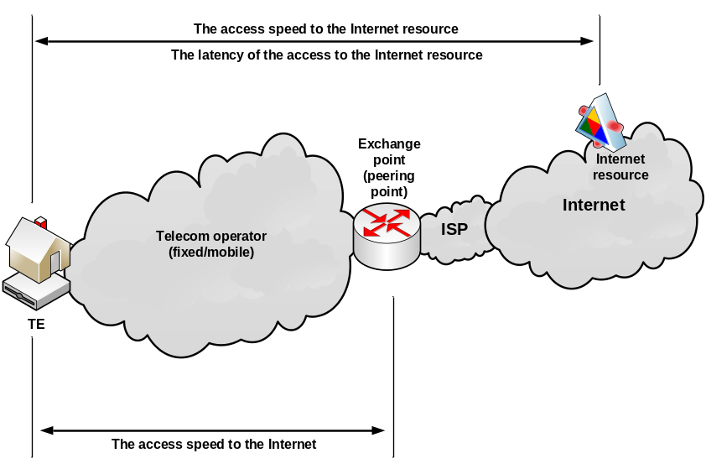
Figure 1 Type of measured parameters

Architecture of measurement system
In accordance with above measured parameters, there are two different types of measurement system should be used:
- the system which can perform end-to-end testing among operator’s customer and external interface of exchange point (peering point) (Figure 2.);
- the system which can perform end-to-end testing among operator’s customer and relevant Internet resource (Figure 3).
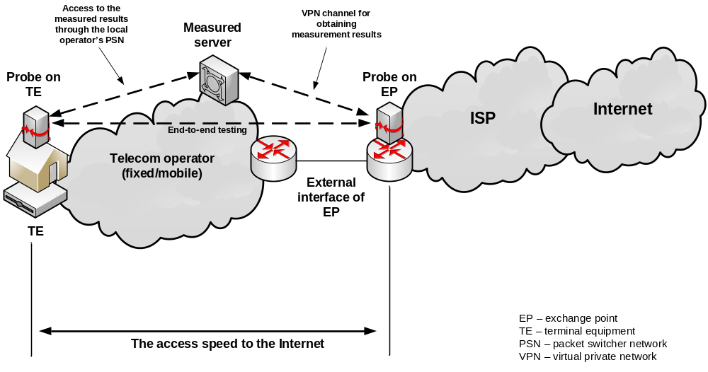
Figure 2. The architecture of measured system to perform end-to-end testing among operator’s customer and external interface of exchange point (peering point)
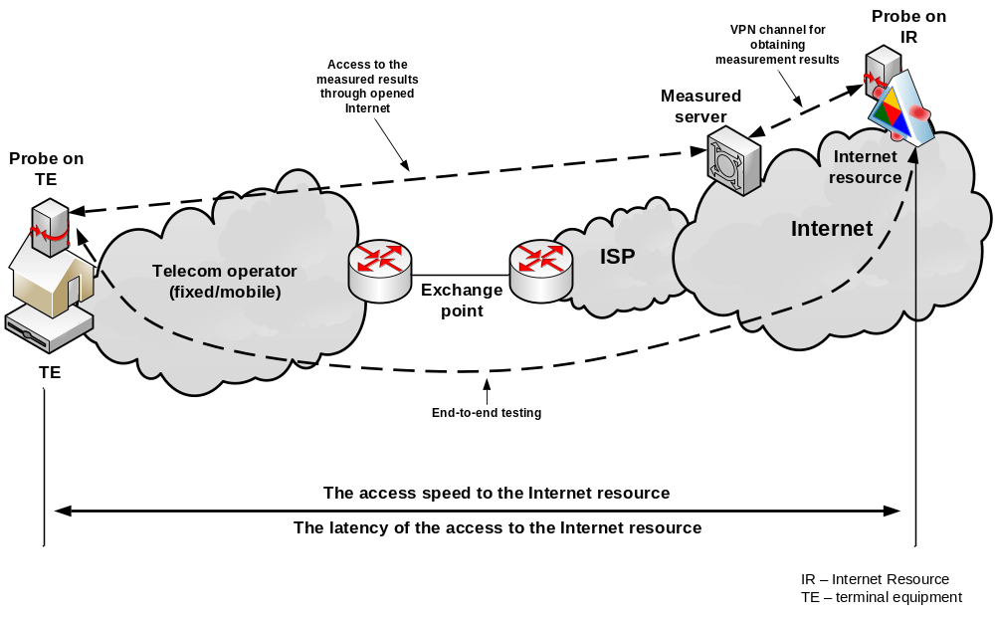
Figure 3. The architecture of measured system to perform end-to-end testing among operator’s customer and relevant Internet resource

Disadvantages of the existing methods of data speed measurement
The existing data speed measurement systems which are also available in the Internet have several issues which does not provide the guaranteed measurement results and therefore could not be used on the telecom operator’s networks. These issues include:
- the obtained test results, which were achieved by one method, may vary from results achieved by other method which probably can be caused by estimated network segments (not guarantee that measurement does not include other Internet segments, non telecom operator’s network);
- The results of measurements can be affected by the following factors:
- overload of the measured server;
- hardware configuration and performance of the user's terminal;
- the installed software and/or performance of an user's terminal at the time of measurement;
- network status (busy hour) and usages of Internet connection/Internet resources during measurement;
- usages of security software (firewalls, anti-virus) on the network and the subscriber terminal at the time of measurement.
- For "accuracy" results some of the existing methods make several attempts at different times of measurement where the time period is not specified (does not account the busy hour).
- The random measurement is to be used during the testing.
- Processing of the values will include dropping to 40% of the measurement results, which eliminates the possibility of identification and valuation of method error.

Requirements to the test methodology to estimate the access speed to the Internet
The method of measuring the access speed to the Internet should meet the following basic requirements:
- transparency and validity;
- accuracy;
- repeatability, consistency with the protocols and used interfaces on TE;
- natural conjugation with the assessment of the quality of telecommunications services in general;
- accessibility to the user;
- accessibility to the Internet provider.

Measurement algorithm to assess the access speed to the Internet
Initial positions of the proposed method are as follows:
- Client-Server architecture is to be used for measurement. Measurement is carried out by transmitting data streams in both direct and reverse directions between the server and the client (by user’s web browser).
- The server constitutes hardware and software system and is the mean of measuring with characteristics (timestamp accuracy + / - 1 ms, the frame length error of + / - 1 bytes).
- Data packets for measurement of speed and quality of transfer during Internet access are formed in TCP / IP stack and use the following protocols Ethernet, IP, TCP и HTTP stack. For transfer of management data and test data a standard protocol port HTTP – 80 is used. Format of the data packet is shown in the Table:
Ethernet | IP | TCP | HTTP | Data

- Measurement equipment – servers are located in the Internet traffic exchange points.
- Development of requirements for the measurement signal parameters (parameters will be defined during the development of recommendations)
- Each packet of test signal is labeled with number (N) and time of sending (TS) at the world clock.

The measurement procedure
- The Client initiates a connection with the Server via HTTP.
- Web page that is opened on the Server which is sent to the Client and the script with the commands to carry out the measurement on the Client’s part runs.
- Before the measurement of each parameter the Client and the Server synchronize the internal clock via NTP.
- The Client and the Server exchange packets with a data field in the format:

0...15 bit | 16...31 bit
Magic Number | Sequence Number
NTP Time Stamp
NTP Time Stamp
Data
where Magic Number (16 bit) – unique protocol identifier (C0FE); Sequence Number (16 bit) – packet sequence number; NTP Time Stamp (64 bit) – time in world clock; Data – data up to 16438 bytes (the relevant part of the measurement signal - random numeric sequence).
- Client in a result of the script work generates a table in which for each package shall be included: a packet number (N), the packet length (L), the time of sending the packet (TS) and time of receipt of the packet (TE). Table transferred to Server.
- The client runs a script with command to carry out measurements on the server side. Having conducted similar measurements, the Server generates a table, in which the same measurement data is recorded. Tables can be stored on a separate server, accumulating database of measurement results.
- For the delay measurement 300 test package per hour or 5 package per minute are used. The size of each packet is random and constitutes 64, 128, 256, 512, 1024, 1280 or 1514 byte. For each test packet start time of transmission of the packet from the client and the time of completion of the IP packet to the server is recorded. The results of each measurement of delay are stored in the table. Figure of the delay is calculated as follows: 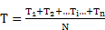, where N – the number of measurements (equally 300), – the result of momentary measurement of the delay.
- The server processes the data to determine the speed of Internet access for both downlink and uplink streams VC and VS, the ratio of the received packets to the number of transmitted for both streams IC and IS and calculates delay variation, confidence intervals, and the average quadratic values ​​of the restored realization of a random process Qm and Qσ, as well as fidelity of transfer for both downlink and uplink streams AC and AS as the ratio of correctly received symbols to their total number in the measurement signal.

Evaluation of inaccuracy of a measured results
Benchmarking amount of information in the measuring sequence is known in advance with absolute error Δ_{IE}. Actual value Δ_{IE} does not exceed ± 1 bit. However, since the absolute error of the model reference measuring instruments is ± 1 byte, to the legitimacy of the results of measurements and taking into account the process of verification measuring instruments (the server) appropriate to take error of the amount of information in the measurement sequence equal to not less than ± 1 byte (eg, ± 2 bytes) .
Error of direct measurement of current time values corresponding to the selected events in the process of transmission (reception) of the sequence of packets of information through clocks of sending (receiving) computer contains the following essential components:
- systematic component, defined by divergence of time scale of computer’s clock with time scale UTC (SU), supported by the State primary standard of time, frequency and national time scale;
- systematic component, defined by the delay of time between the operation of registration of the current time on the computer’s clock and the operation of actual transmission (reception) of the initial part of the packet;
- for the delays of packet transmission - systematic component due to differences of time scales of measuring instruments’ clock and clock of the user’s equipment (asynchrony),
- the amount of random components, determined by unknown factors, determined by statistical methods.

Requirements to the test methodology to estimate the access speed to the Internet resources
TBD

Bibliography
https://support.speedtest.net/entries/20862782
http://www.testskorosti.ru/
http://speedmeter.de
http://2ip.ru/speed/
http://pr-cy.ru/speed_test_internet
https://itunes.apple.com/ru/app/net-speed-test-lite/id471993926?mt=8
http://www.speed.io
http://www.voiptest.org/
http://speedtest.south.rt.ru/#
http://myconnect.ru/speed
http://wi.test
___________________________

